Johannes Vermeer
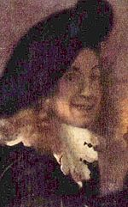
Detail of The Procuress, possibly a self-portrait, painted 1656.
Born | Baptized 31 October 1632  Delft, Dutch Republic
Died | 15 December 1675 (aged 43)  Delft, Dutch Republic
Nationality | Dutch
Field | Painting
Movement | Baroque
Works | About 35 paintings have been attributed
 | Influenced by Carel Fabritius, Leonaert Bramer, Dirck van Baburen?
Édouard Manet
portrait by Nadar
Birth name | Édouard Manet
Born | 23 January 1832  Paris
Died | 30 April 1883 (aged 51)  Paris
Nationality | French
Field | Painting
Movement | Realism, Impressionism
Works | The Luncheon on the Grass (Le déjeuner sur l'herbe), 1863  Olympia, 1863  A Bar at the Folies-Bergère (Le Bar aux Folies-Bergère), 1882  Young Flautist or The Fifer (Le Fifre), 1866

Claude Monet
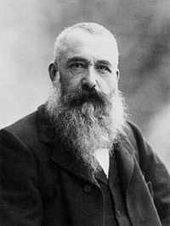
Claude Monet, photo by Nadar, 1899.
Birth name |  | Oscar Claude Monet
Born |  | 14 November 1840  Paris, France
Died |  | 5 December 1926 (aged 86)  Giverny, France
Nationality |  | French
Field |  | Painter
Movement |  | Impressionism
Works |  | Impression, Sunrise  Rouen Cathedral series  London Parliament series  Water Lilies  Haystacks  Poplars
Patrons |  | Gustave Caillebotte, Ernest Hoschedé, Georges Clemenceau
Influenced by |  | Eugène Boudin, Johan Jongkind, Gustave Courbet

Paul Gauguin
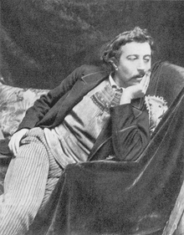
Paul Gaugin, 1891
Birth name | Eugène Henri Paul Gauguin
Born | 7 June 1848  Paris, France
Died | 8 May 1903 (aged 54)  Atuona, Marquesas Islands, French Polynesia
Field | painting, sculpture, ceramics, engraving
Movement | Post-Impressionism, Primitivism
Influenced | Edvard Munch

Vincent van Gogh
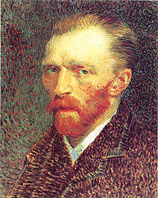
Self-portrait (1887), Art Institute of Chicago
Birth name | Vincent Willem van Gogh
Born | 30 March 1853  Zundert, Netherlands
Died | 29 July 1890 (aged 37)  Auvers-sur-Oise, France
Nationality | Dutch
Field | Painter
Movement | Post-Impressionism
Works | The Potato Eaters, Sunflowers, The Starry Night, Irises, Portrait of Dr. Gachet
Influenced by | Anton Mauve, Jean-François Millet, Adolphe Joseph Thomas Monticelli, Impressionism

Gustav Klimt
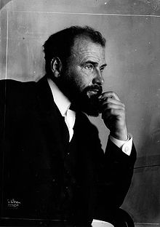
Gustav Klimt, 1908. Photo by Dora Kallmus.
Birth name | Gustav Klimt
Born | July 14, 1862  Baumgarten, Austrian Empire
Died | February 6, 1918 (aged 55)  Vienna, Austria-Hungary
Nationality | Imperial Austrian
Field | Painter
Movement | Symbolism, Art Nouveau
Works | Judith and the Head of Holofernes, Portrait of Adele Bloch-Bauer I, The Kiss, Danaë
Influenced | Egon Schiele

Henri de Toulouse-Lautrec
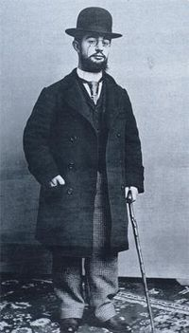
Henri de Toulouse-Lautrec.
Birth name | Henri Marie Raymond de Toulouse-Lautrec-Monfa
Born | 24 November 1864  Albi, Tarn, France
Died | 9 September 1901 (aged 36)  Château Malromé, France
Nationality | French
Field | Painter, Printmaker, draftsman, illustrator
Movement | Post-Impressionism, Art Nouveau

Wassily Kandinsky
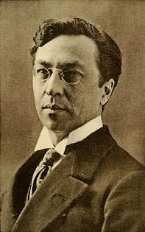
Wassily Kandinsky, c. 1913 or earlier
Birth name | Wassily Wassilyevich Kandinsky
Born | 4 December 1866  Moscow
Died | 13 December 1944 (aged 78)  Neuilly-sur-Seine
Nationality | Russian
Field | Painting
Training | Academy of Fine Arts, Munich
Movement | Expressionism; abstract art
Works | On White II, Der Blaue Reiter

Henri Matisse
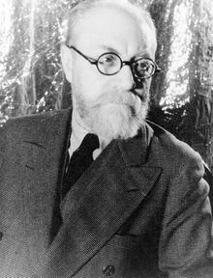
Photo of Henri Matisse by Carl Van Vechten, 1933.
Birth name | Henri-Émile-Benoît Matisse
Born | 31 December 1869  Le Cateau-Cambrésis, Nord
Died | 3 November 1954 (aged 84)  Nice, Alpes-Maritimes
Nationality | French
Field | painting, printmaking, sculpture, drawing, collage
Training | Académie Julian, William-Adolphe Bouguereau, Gustave Moreau
Movement | Fauvism, Modernism
Works | Woman with a Hat (Madame Matisse), 1905 in museums:  - Museum of Modern Art  - Barnes Foundation
Patrons | Gertrude Stein, Etta Cone, Claribel Cone, Michael and Sarah Stein, Albert C. Barnes
Influenced by | John Peter Russell, Paul Cézanne, Paul Gauguin, Vincent van Gogh, Paul Signac
Influenced | Hans Hofmann, David Hockney, Tom Wesselmann

Pablo Picasso
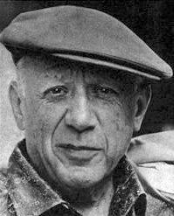
Pablo Picasso in 1962
Birth name | Pablo Diego José Francisco de Paula Juan Nepomuceno María de los Remedios Cipriano de la Santísima Trinidad Ruiz y Picasso^{[1]}
Born | 25 October 1881  Málaga, Spain
Died | 8 April 1973 (aged 91)  Mougins, France
Nationality | Spanish
Field | Painting, Drawing, Sculpture, Printmaking, Ceramics
Training | Jose Ruíz (father), Academy of Arts, Madrid
Movement | Cubism
Works | Les Demoiselles d'Avignon (1907)  Guernica (1937)  The Weeping Woman (1937)

