**"The Appointment in Samarra"   
(as retold by W. Somerset Maugham [1933])**

**The speaker is Death**

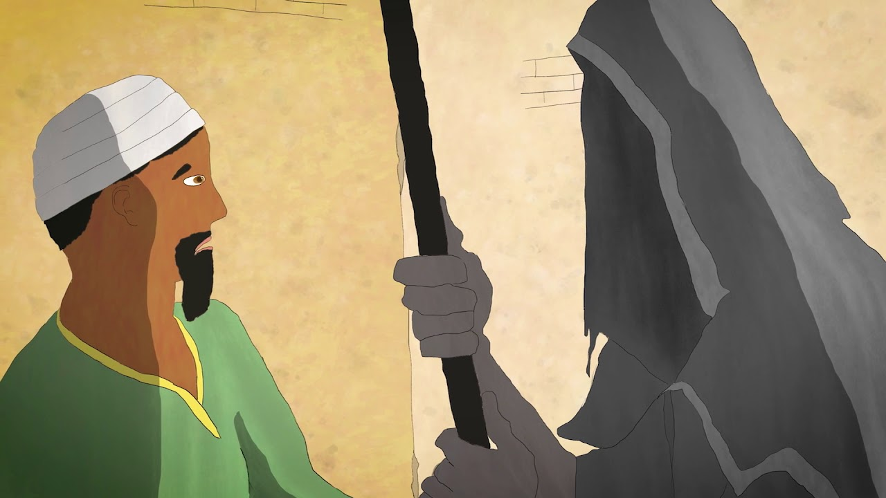

There was a merchant in Bagdad who sent his servant to market to buy provisions and in a little while the servant came back, white and trembling, and said, Master, just now when I was in the marketplace I was jostled by a woman in the crowd and when I turned I saw it was Death that jostled me. She looked at me and made a threatening gesture, now, lend me your horse, and I will ride away from this city and avoid my fate. I will go to Samarra and there Death will not find me. The merchant lent him his horse, and the servant mounted it, and he dug his spurs in its flanks and as fast as the horse could gallop he went. Then the merchant went down to the marketplace and he saw me standing in the crowd and he came to me and said, Why did you make a threatening gesture to my servant when you saw him this morning? That was not a threatening gesture, I said, it was only a start of surprise. I was astonished to see him in Bagdad, for I had an appointment with him tonight in Samarra.