**Addiction**

Natural addictions to things like (1), (2), (3), are good because they are important for our (4) and (5). We aren’t exactly (6) with them; rather, our (7) creates them.

For example, when (8) into an apple, your (9) recognizes that this apple is good for you and releases a (10) called dopamine. Dopamine causes you to experience (11), that is, to feel good. It teaches your body that what you’re doing is healthy and good for your (12) and that you should remember to do it again.

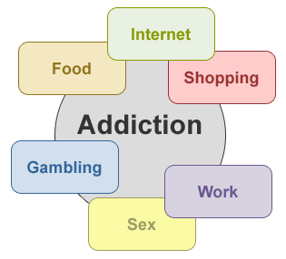Other things that we do release the pleasurable dopamine, like playing (13), (14), or (15) a good book. The amount is less, however, so that the brain recognizes which is more important. So if you go 2 days without reading a book or 2 days without eating food, your body is going to (16) the food over the book. A (17) of survival is created in this way, which ranks how important each of these things is for your survival.

Alcohol, marijuana, (18) and other (19) are all classified as carcinogens, that is, (20) that are proven to cause cancer. Your brain should (21) that these things are harmful to your body. However, these substances have special chemical (22) that fool the brain into releasing dopamine, oftentimes in much greater amounts than the body has ever experienced before.

In this way, the body is fooled into thinking that these things are good and more important than food, water or (23) and consequently (24) the number 1 spot in your survival (25). So now, if you go 2 days without eating or 2 days without drinking alcohol, your body will actually (26) the alcohol over the food.

This is an (27) case of addiction where the person addicted believes they will (28) if they don’t get it. The severity of the addiction can increase even with (29) use.

If you’re under 21, you are at the highest (30) of having your survival (31) hijacked because your brain is still growing and (32) and is hypersensitive to false shocks of dopamine caused by these harmful substances.

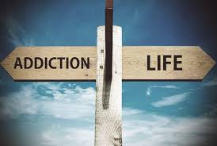By 21, your brain is more fully (33) and mature and your survival hierarchy becomes more (34) and less (35) to getting hijacked. On the flipside, once you’re 21, it’s very difficult to remove these harmful (36) from your survival hierarchy.

9 out of 10 people currently (37) with addiction started drinking, (38) or using before the age of 21.

If we understand that addiction is a (39) disease, and if we decide to wait until 21, this can mean the difference between a life (40) by addiction or a life full of success and (41).