Damien Rice

The Blower's Daughter Lyrics

https://www.youtube.com/watch?v=5YXVMCHG-Nk
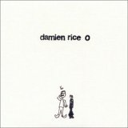
And so it
Just like you said it would
goes easy on me
Most of the
And so it
The shorter
No love, no glory
No hero in her
I can't take my eyes off of you
I can't take my eyes off you
………………………………..
And so it is
Just like you said it should be
We'll both the breeze
Most of the time
And so it is
The colder
The blower's daughter
The pupil in denial
I can't take my eyes off of you
I can't take my eyes off you
………………………………..
Did I say that I loathe you?
Did I say that I want to
Leave it all ?
I can't take my mind off of you
…………………………………..
My mind...my mind...
'Til I find somebody

