**Student’s Book, pg 21**

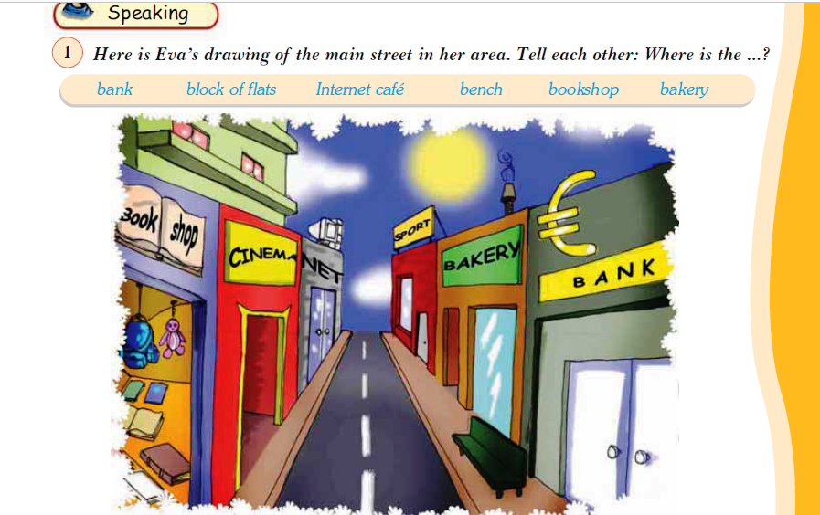

**behind between in front of**

**near next to opposite**

1. The bank is to the bakery.
2. The bench is the bakery.
3. The block of flats is the Internet café.
4. The cinema is the bookshop and the Internet café.
5. The cinema is the bakery.