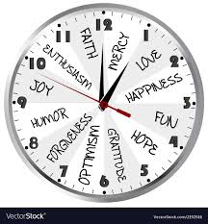**Don’t Get Me Wrong_**[**The Pretenders**](https://www.google.com/search?safe=strict&sxsrf=ACYBGNTXF0FpIkrZ0bmRd_JJ_POcmGoIPw:1573024103400&q=The+Pretenders&stick=H4sIAAAAAAAAAONgVuLUz9U3MDSqMMxZxMoXkpGqEFCUWpKal5JaVAwAp-ZaGB4AAAA&sa=X&ved=2ahUKEwiO45-3g9XlAhWODewKHW1cC2QQMTAAegQICxAF)

[**https://www.youtube.com/watch?v=IRaO9112mco**](https://www.youtube.com/watch?v=IRaO9112mco)

Don't get me wrong  
If I'm looking kind of dazzled  
I see neon lights  
Whenever you walk by

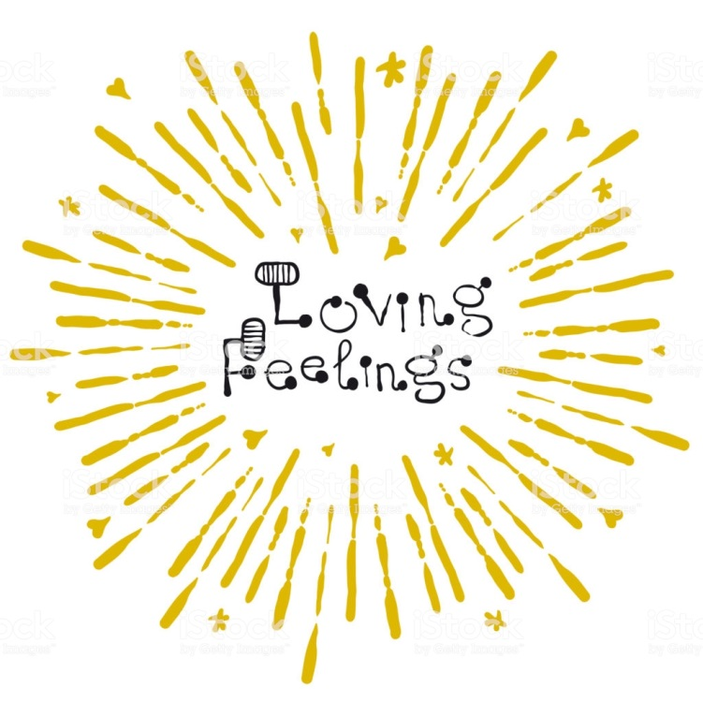Don't get me wrong  
If you say, "hello", and I take a ride  
Upon a sea where the mystic moon  
Is playing havoc with the tide  
Don't get me wrong

Don't get me wrong  
If I'm acting so distracted  
I'm thinking about the fireworks  
That go off when you smile

Don't get me wrong  
If I split like light refracted  
I'm only off to wander  
Across the moonlit mile

Once in a while , two people meet  
Seemingly for no reason  
They just pass on the street  
Suddenly, thunder, showers everywhere  
Who can explain the thunder and rain?  
But there's something in the air

Don't get me wrong  
If I come and go like fashion

I might be great tomorrow  
But hopeless yesterday

Don't get me wrong  
If I fall in the mode of passion  
It might be unbelievable  
But let's not say, "so long "  
It might just be fantastic  
Don't get me wrong

