**Activity 7, pg 8**

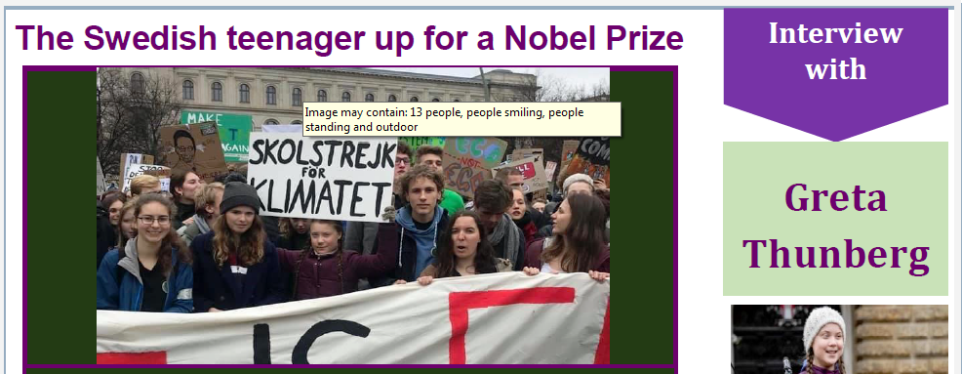

**Comprehension Questions**

1. How old is Greta?
2. Where is she from?
3. What is she famous for?
4. Why does she go on strike from school?
5. According to Greta, who can make a difference?
6. What has she recently been nominated for?
7. How does she feel about that? Why?
8. How does she feel about our planet’s future?